HAYSA Adding Player or Coach Headshot Photos

- South Shore Soccer League - Headshot Requirements
  - Only 1 person per photo
  - Taken from the front
  - No face coverings or sunglasses
  - Minimize shadows
  - Headshot should be the size of a quarter

- Log in to HAYSA team sideline account
  - Go to: https://www.haysa.org/home
    - Select Sign In
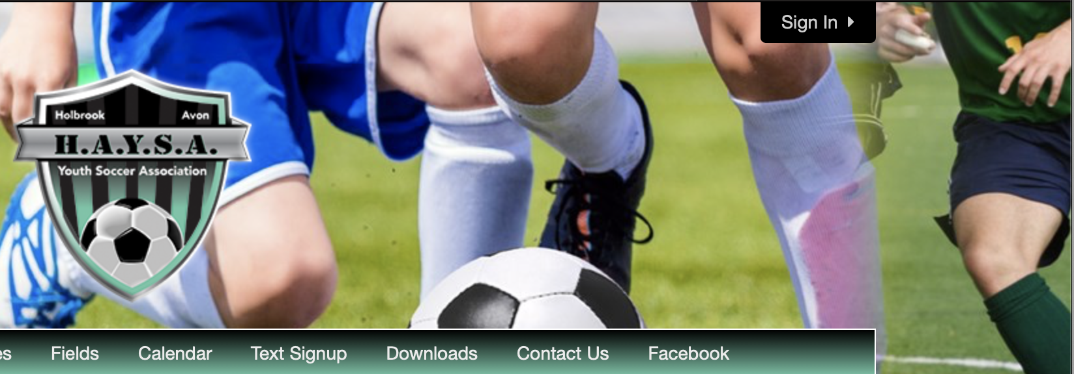
    - Sign in to your TeamSideline account
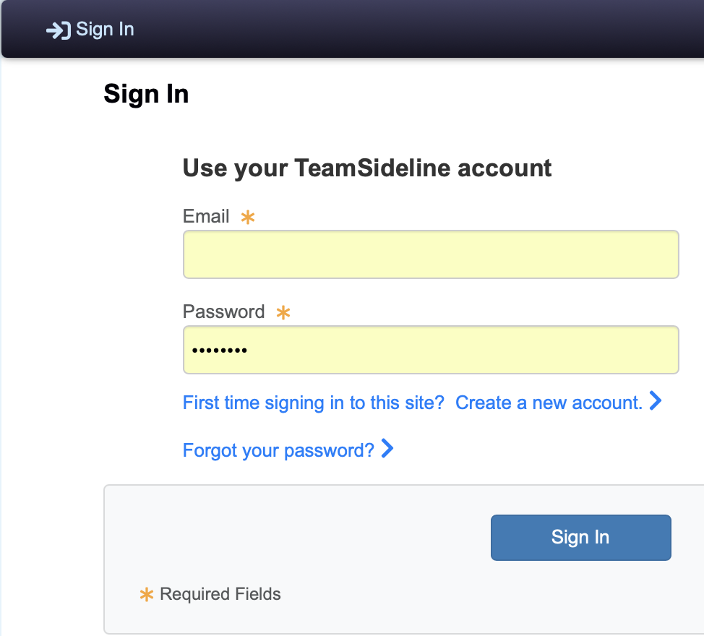

  - Go to My Account Members
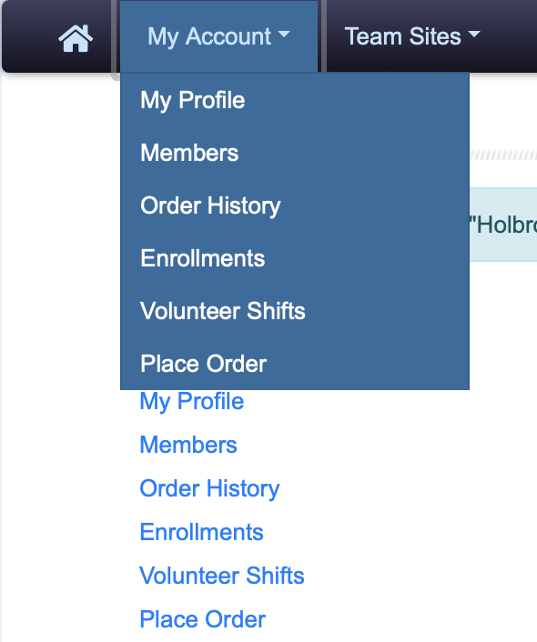

    - Find the member and select the edit button
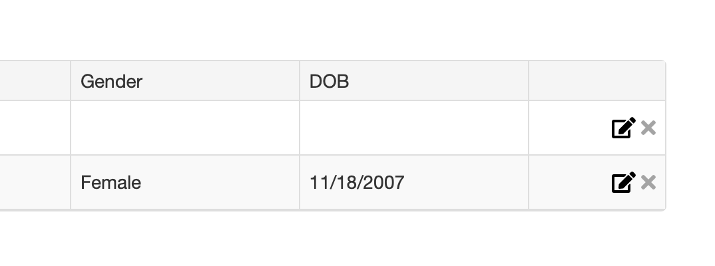
    - Remove the default picture
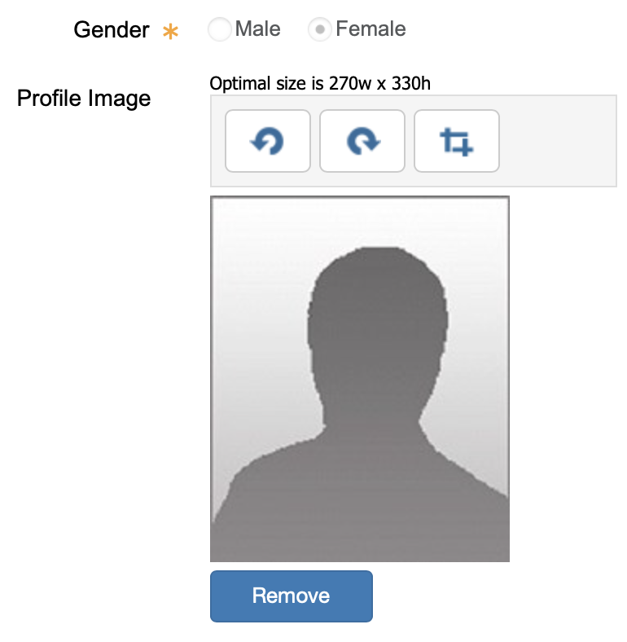
    - Add new picture
      - Hit select to find an image on your device to upload
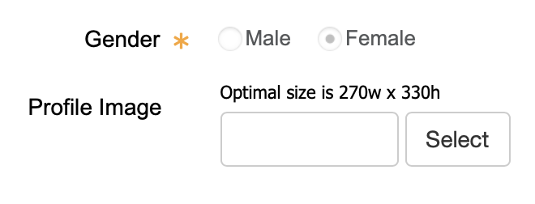
      - Review picture
        - Use tools to edit photo


